CEP - Promotional Messaging Scripts

MESSAGING FOR SPONSORED REFUGEES

Email Message (Edit to suit your organization)

Dear…………..,

- Did you come to Canada as a Sponsored Refugee between 1997 to 2015?

- Did your early settlement experience affect your work opportunities?

- Want to share your experience to help others?

The Citizenship and Employment Precarity (CEP) research project is looking for persons who arrived in Canada as Sponsored Refugees to complete an online survey. The CEP survey is for persons who currently live in the Greater Toronto Area and have lived and worked in Canada at least 3 years. The project will analyze how immigration status experiences affect work opportunities and well-being.

Make Your Experience Count!

- The survey is completely confidential. No name or identifying info. is required

- It takes approximately 25 minutes

- Receive a $10 Tim Hortons e-gift card upon completion

Go to www.cep.info.yorku.ca

The CEP project is run by researchers at York University and the University of Toronto in collaboration with community groups across the GTA. For more information, email cep@yorku.ca.

Facebook and LinkedIn Messages
Edit and/or chose the most suitable one for your organization.

Message 1
Did you come to Canada as a Sponsored Refugee between 1997 - 2015? Share your experience through the CEP immigration and work survey. Get a $10 Tim Hortons e-gift card! www.cep.info.yorku.ca

Message 2
Your experience matters! Did you come to Canada as a sponsored refugee? Share your work and settlement experience through the CEP immigration and work survey for a Tim Hortons e-gift card! www.cep.info.yorku.ca

Twitter Messages
Edit and/or chose the most suitable one for your organization.

Message 1
Did you come to Canada as a Sponsored Refugee between 1997 - 2015? Share your experience through the CEP immigration and work survey. Get a $10 Tim Hortons e-gift card! www.cep.info.yorku.ca #cdnimm #GTA #TO

Message 2
Your immigrant experience matters! Share your story through the CEP immigration and work survey for a $10 Tim Hortons e-gift card! www.cep.info.yorku.ca #cdnimm #GTA #TO

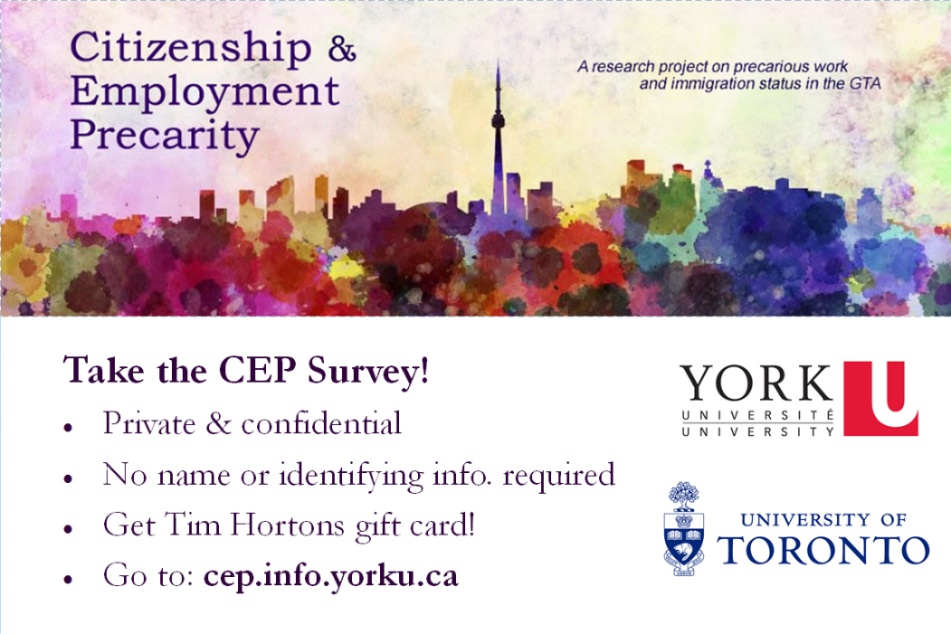
CEP banner image for social media messaging

